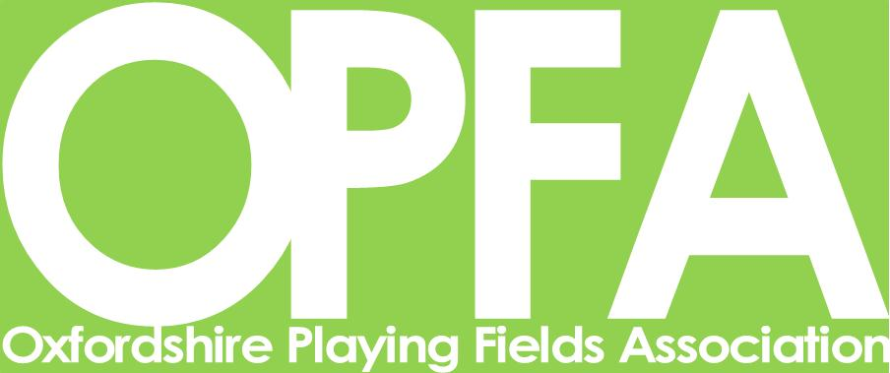
List of Information Sheets Available
(as at September 2023)

The Oxfordshire Playing Fields Association produces information sheets on various aspects of outdoor recreational spaces.
The current list is as follows:
- Accidents
- Accessible Play Areas
- Balls Walls
- BMX Info
- Draft Constitutions
- Playground Fencing and Gates
- Funding Opportunities
- Playground Inspections
- Insurance
- Managing Charitable Playing Fields
- Maintenance Contractors
- Pitch maintenance
- Playground Notices
- Planning and Providing for a Wheeled Sport Facility
- Problems with Dogs
- Project Plan – Play Area Development
- Project Plan – Skate Park Development
- Risk Management and Risk Assessments
- Playground Legislation, Standards and Guidelines
- Outdoor Fitness Equipment
- The Use of Glyphosate Weedkiller
- Sports Pitch Maintenance
- Toxicara Canis
OPFA will continue to produce further information sheets in response to need. In addition, we have access to information from many of our partner organisations.

